|  |  |
| --- | --- |
| 1 | Addition of two 4x4 matrices |

|  |
| --- |
| **Code** |

% Matrix A definition

A = [ 5 4 6 3;

17 8 39 10;

25 7 63 7;

9 47 5 36];

% Matrix B definition

B = [ 12 5 17 61;

1 32 71 6;

21 41 32 12;

12 41 31 10];

% Performs Addition and Shows Output

C = A + B

|  |
| --- |
| **Output** |

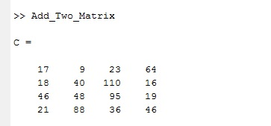

|  |  |
| --- | --- |
| 2 | Generate Random Number |

|  |
| --- |
| **Code** |

% Takes input

n = input('How many number do you want: ');

% Generates random numbers multiplying by 1000

A = rand(1,n)*1000;

% Suppress decimal fragment part and shows output

A = floor(A)

|  |
| --- |
| **Output** |

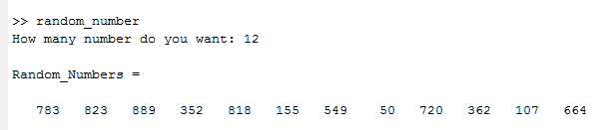

|  |  |
| --- | --- |
| 3 | Temperature Vs. Month Plot |

|  |
| --- |
| **Code** |

% Declaring months

Month = {'January' 'February' 'March' 'April' 'May' 'June' 'July' 'August' 'September' 'October' 'November' 'December'};

% Declaring temperature in every month

Tem = [12 14 25 24 28 33 36 32 22 24 20 18];

% Plotting 12 months vs. temperature graph

plot(1:12,Tem);

xlabel('Months'); ylabel('Temperature');

title('Temperature flow in every month');

% Setting months name in X axis

set(gca,'xtick',1:length(Month), ...

'xticklabel',Month)

|  |
| --- |
| **Output** |

